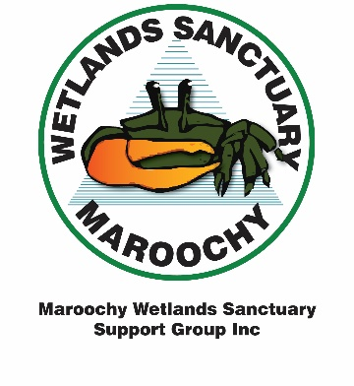
Maroochy Wetlands Sanctuary
Support Group Inc.
PO Box 32, Bli Bli Qld 4560
Phone: (07) 5448 6723
Email: mwssgi@gmail.com
Website: www.maroochywetlandssupport.org.au
MEMBERSHIP APPLICATION / RENEWAL FORM
Subscriptions are paid annually and are due on 1 October
☐ | NEW MEMBER | ☐ | RENEWAL
APPLICANT
Given Names |  | Surname | Click here to enter text.
Email | Click here to enter text.
Home Phone | Click here to enter text. | Mobile
Partner (if a member / joining)
Given Names | Click here to enter text. | Surname | Click here to enter text.
Email | Click here to enter text. | Mobile | Click here to enter text.
Home Address | Click here to enter text.
City/Surburb | Click here to enter text. | Postcode | Postcode | State | State.
Postal Address | Click here to enter text.
City/Surburb | Click here to enter text. | Postcode | Postcode | State | State.

ANNUAL FEES / PAYMENT DETAILS
Standard  Family / Couple  Single | Fee  $30.00  $20.00 | Total  $ Amount |  | PAYMENT  Post this form to the above address with a cheque payable to “Maroochy Wetlands Sanctuary Support Group Inc.”  OR  Pay by EFT or Direct Deposit*:  Account Name: Maroochy Wetlands  Sanctuary Support Group Inc.  BSB: 084-801  Account No: 55-201-0901  Ref/Description: Surname / subs
Concession  Family / Couple  Single or Student | $25.00  $15.00 | $ Amount
Donation |  | $ Amount
Total Amount |  | $ Amount
*Please return this completed form by mail or email to the Secretary confirming your payment by EFT or Direct Deposit
with the following details: Bank payment lodged at, sum paid, date and reference used.

Date | Enter date

All members automatically receive the Support Group web based newsletter.
Should you wish NOT to receive this newsletter please tick here:

MWSSGI is proudly sponsored by the Sunshine Coast Council

